**Ziya Atay**

**W69041**

**Course : Programming**

**Topic : My Portfolio**

**Main Page:**

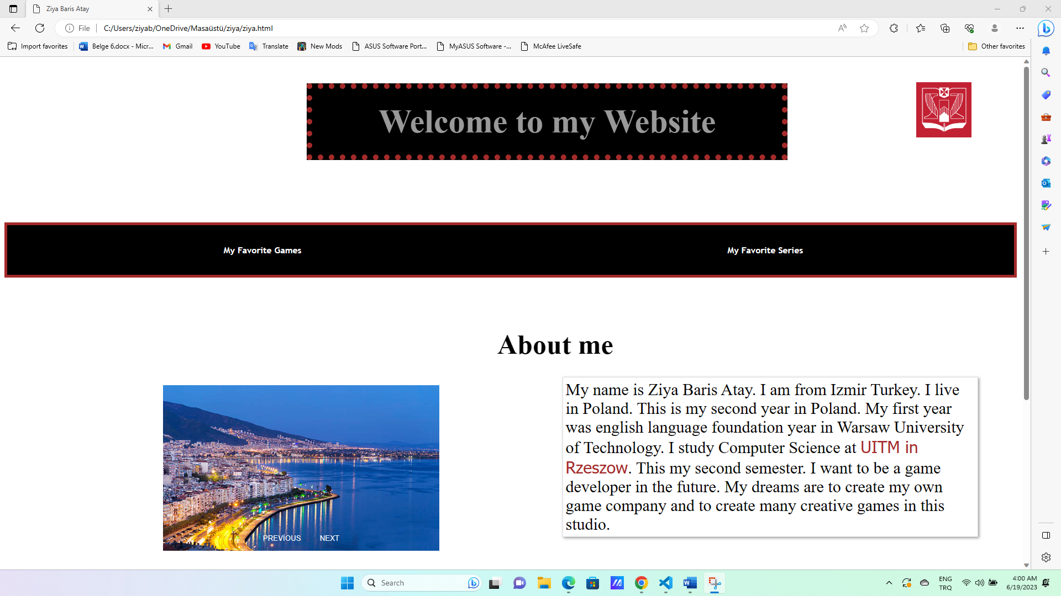

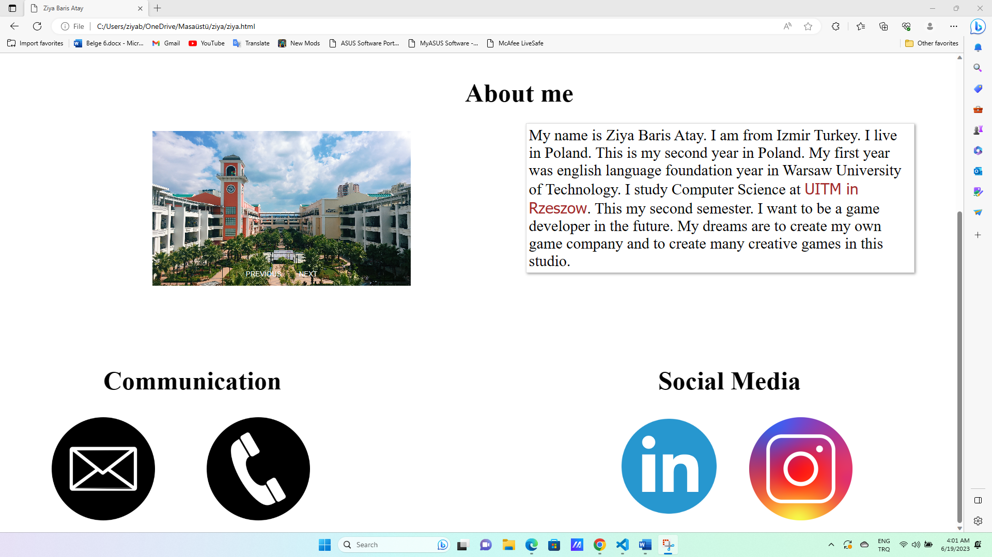

* The HTML document starts with the **<html>** tag, indicating the beginning of the HTML code.
* Inside the **<head>** section, the document title is set to "Ziya Baris Atay" using the **<title>** tag.
* The **<style>** tag is used to define the CSS styles for the elements in the HTML document.
* The CSS styles define the appearance of various elements, such as links (**a**), headings (**h1**, **h2**, **h3**), paragraphs (**p**), tables (**table**), and images (**img**).
* The styles include properties like font size, color, background color, border, padding, positioning, and transitions.
* The CSS styles also define the hover effect for links, changing the color and removing the underline when the mouse is hovered over them.
* Inside the **<body>** section, the content of the webpage is defined.
* The main heading (**h1**) displays the text "Welcome to my Website" with a decorative border and centered alignment.
* The subheading (**h2**) displays the text "About me" and is positioned in the top right corner of the page.
* A paragraph (**p**) provides information about the author, including their name, location, education, and aspirations. It also contains a link to their university.
* A table (**table**) is created with two cells, each containing a link to different pages ("My Favorite Games" and "My Favorite Series").
* The webpage includes a logo image (**img**) positioned in the top right corner using CSS.
* The contact section includes headings for communication and social media (**h3**).
* Contact information, such as email, phone, Instagram, and LinkedIn, is displayed using images (**img**) wrapped in anchor tags (**a**) with appropriate links.
* A slider section is implemented using a container (**div.slider-container**), containing multiple slides (**div.slide**) with images (**img**).
* CSS classes and JavaScript functions (**nextSlide()**, **prevSlide()**, **showSlide()**) are used to control the slider's behavior, allowing users to navigate between slides manually or automatically.

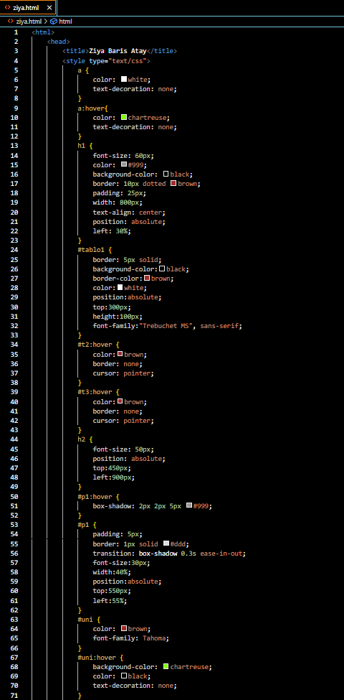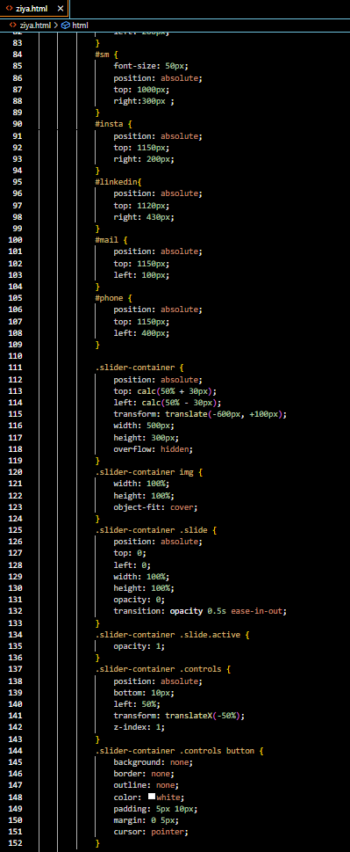

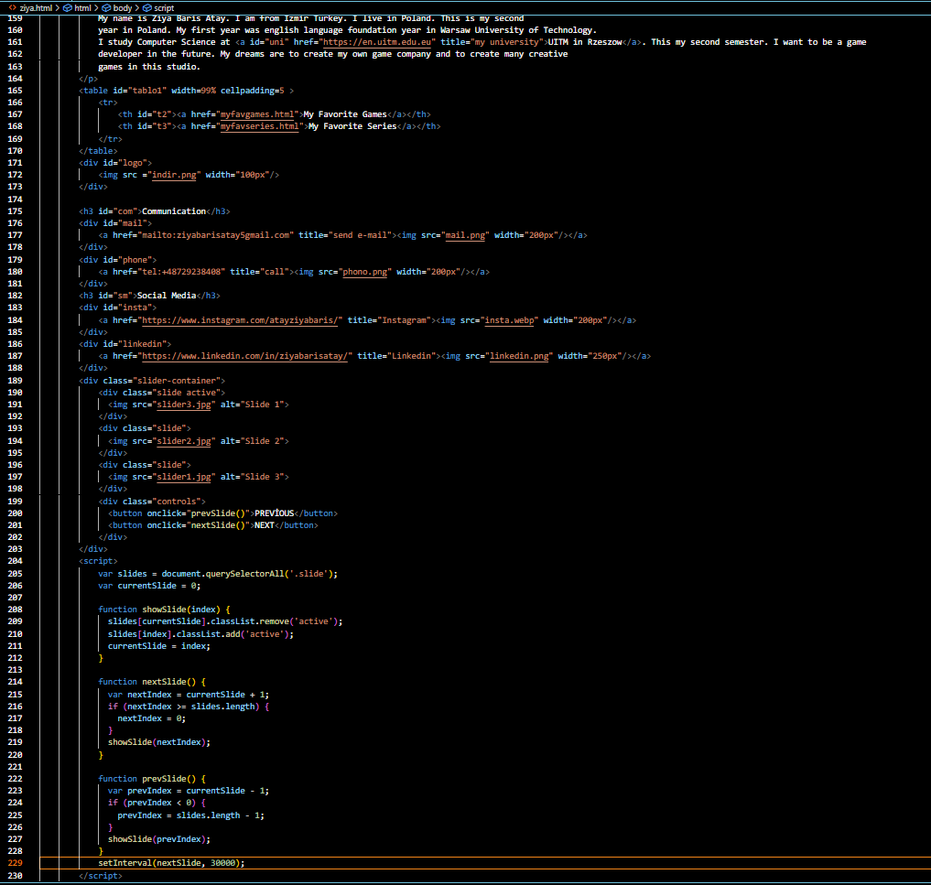

**My Favorite Games(Second Page):**

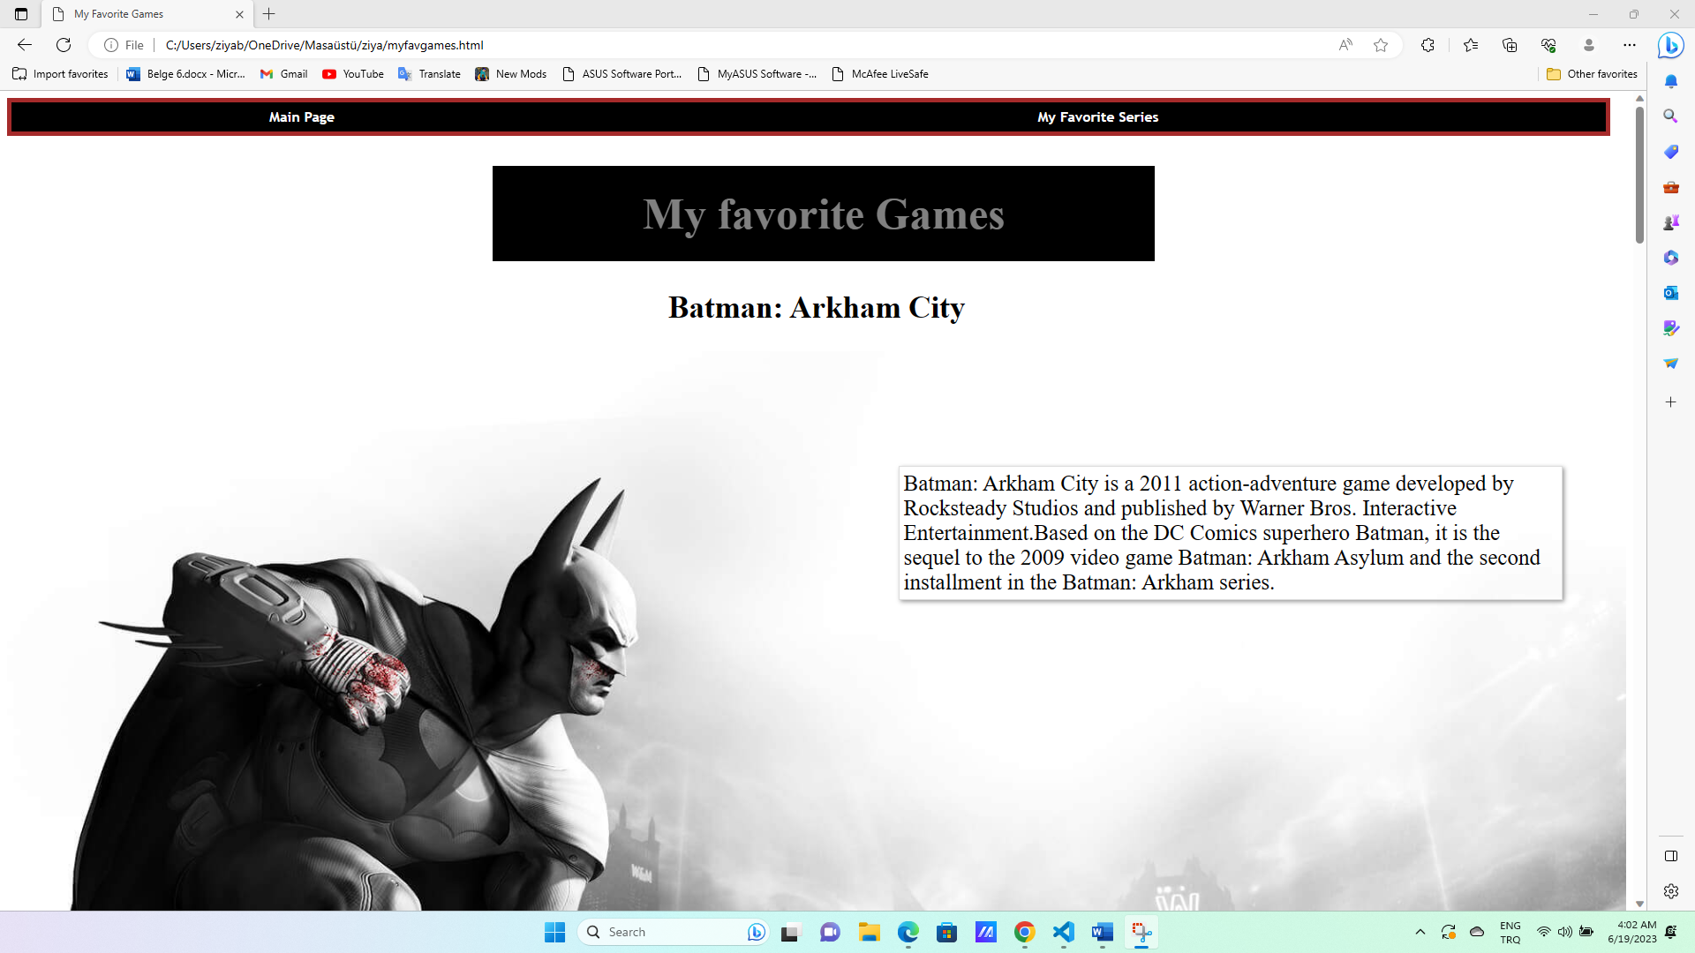

* The HTML document starts with the **<html>** tag, indicating the beginning of the HTML code.
* Inside the **<head>** section, the document title is set to "My Favorite Games" using the **<title>** tag.
* The **<style>** tag is used to define the CSS styles for the elements in the HTML document.
* The CSS styles define the appearance of various elements, such as links (**a**), headings (**h1**, **h2**), paragraphs (**p**), and tables (**table**).
* The styles include properties like color, text-decoration, border, background-color, font-family, padding, position, and width.
* The CSS styles also define hover effects for links and paragraphs, adding color changes and box shadows when the mouse is hovered over them.
* Inside the **<body>** section, the content of the webpage is defined.
* The table (**table**) is created with two rows (**tr**), each containing a header cell (**th**) with a link to different pages ("Main Page" and "My Favorite Series").
* The webpage includes a main heading (**h1**) displaying the text "My favorite Games"  
  with a decorative border, centered alignment, and other styles applied.
* The subheading (**h2**) displays the text "Batman: Arkham City" with center alignment and a font size of 35.
* A paragraph (**p**) provides information about the game "Batman: Arkham City," including its development, publishing details, and its position in the series.
* An image of Batman is displayed using the **<img>** tag, with the source file "batman1.jpg" and a width of 100%.
* An image of Batman is displayed using the **<img>** tag, with the source file "batman1.jpg" and a width of 100%.
* Each section includes a subheading (**h2**), a paragraph (**p**) with information about the game, and an image (**img**) related to the game.
* he CSS styles (**#god_h**, **#god-paragraf**, **#spider-resim**, **#spider-paragraf**, **#nfs_h**, **#nfs-paragraf**, **#gta-resim**, **#gta-paragraf**) are used to position and style these elements within the webpage.
* The paragraphs for "God of War 3," "Marvel's Spiderman," "Need For Speed Most Wanted," and "Grand Theft Auto V" have different background colors and positions using CSS.
* Each image (**img**) has a specific width assigned to control its size within the webpage.
* The closing **</html>** tag marks the end of the HTML code.

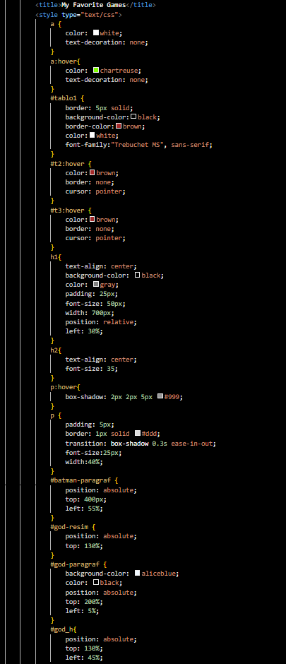

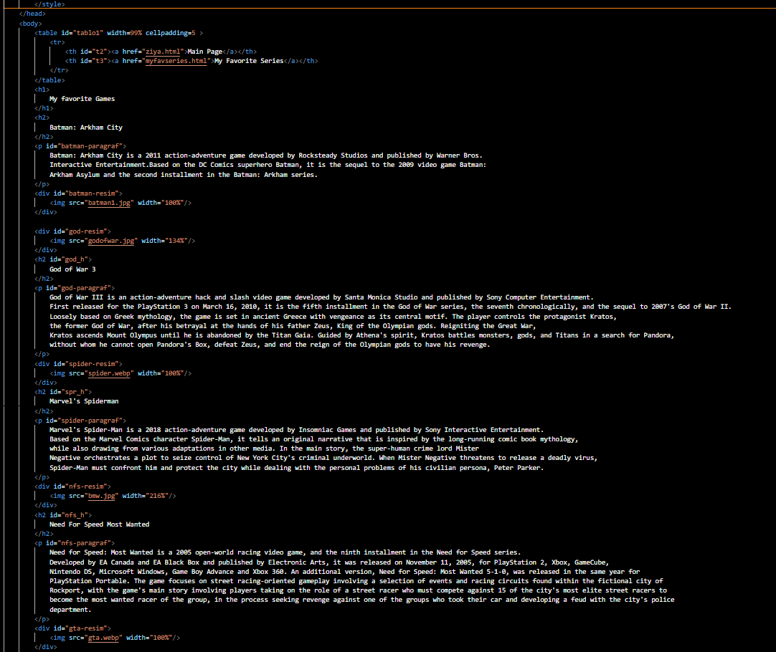

**My Favorite Series(Third page):**

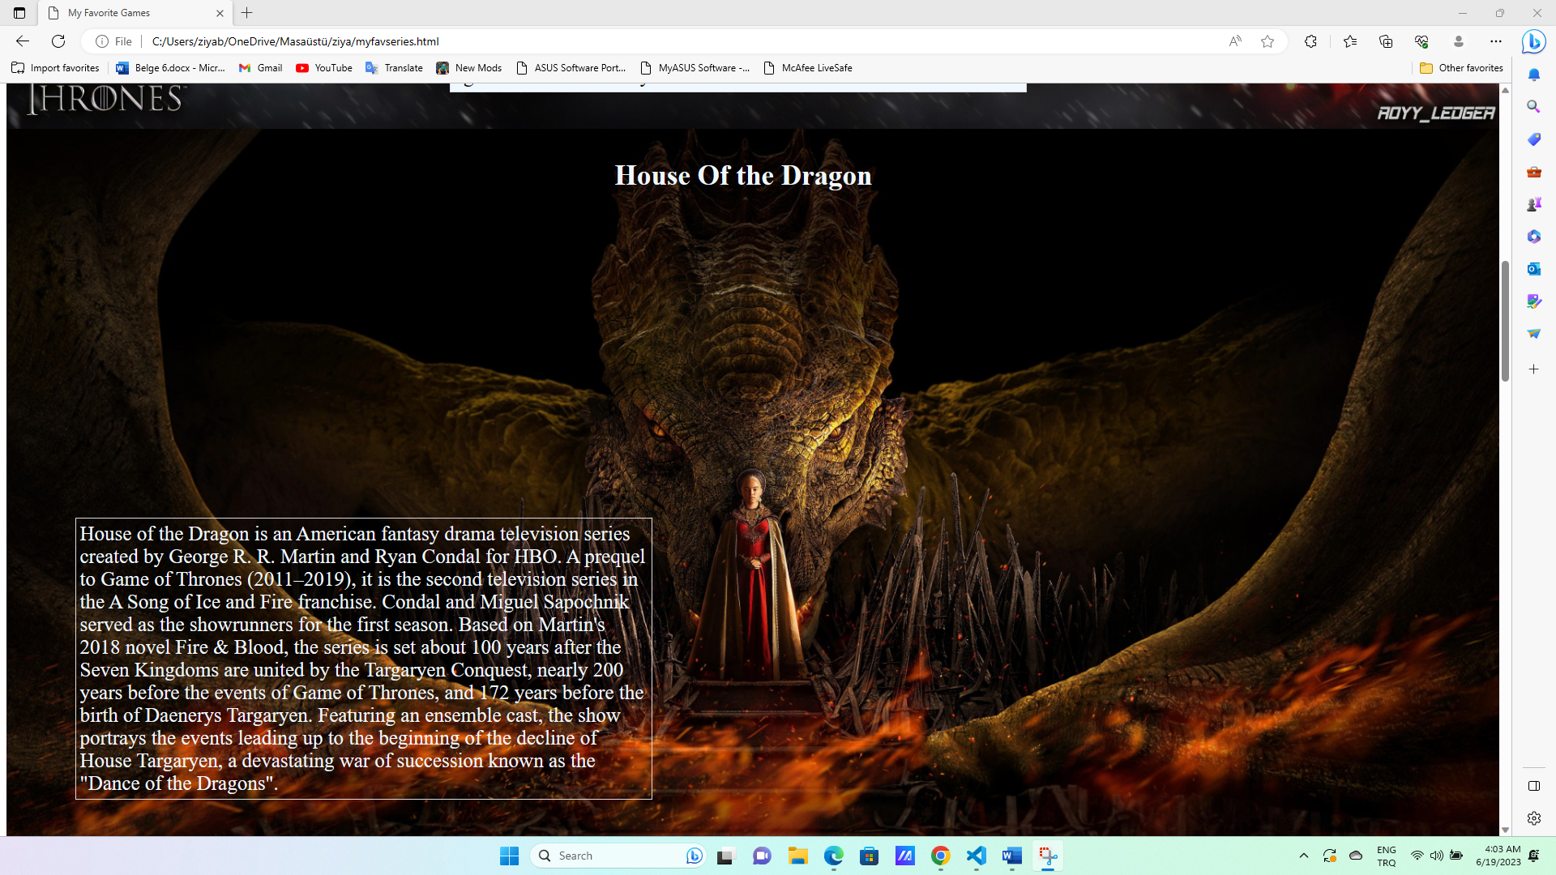

* The code starts with the declaration of an HTML document and includes a **<head>** section where the title and CSS styles are defined.
* The CSS styles define the appearance of different elements such as links (**<a>**), headings (**<h1>**, **<h2>**), and paragraphs (**<p>**). It includes properties for colors, backgrounds, fonts, positioning, and transitions.
* The **<table>** element creates a navigation bar with two links: "Main Page" and "My Favorite Games."
* The **<h1>** element displays the main heading of the page, styled with a black background, gray text color, and centered alignment.
* The content of the page consists of multiple sections, each containing an image and a description of a favorite series.
* Each series section includes an **<img>** tag for displaying the series' image and a **<p>** tag for the description.
* The series described in the page are "Game of Thrones," "House of the Dragon," "Friends," "How I Met Your Mother," and "Breaking Bad."

The given HTML code represents a webpage featuring a list of favorite TV series and games. It incorporates various design elements such as headings, styling, and content sections. The page includes separate sections for each TV series and game, providing a brief description and relevant images. This code allows users to share and showcase their favorite TV series and games in an organized and visually appealing manner. It offers a platform to express personal preferences and engage with others who share similar interests in TV series and games.